State of Michigan

OBRA Automation suite

Workflow-2

CMH submits requested information back to OBRA Reviewer

**Workflows with screenshots:**

**Precondition**:

OBRA Staff has pended the Evaluation with Assessments back to the CMH Coordinator

Step 1:

CMH Coordinator logs in.

Accessing the Pending Queue

From the Main Dashboard, click the PENDING queue button. The screen below will be displayed.

Step 2:

Click the Pending Letter icon as highlighted in orange to display, in PDF format in a

new browser tab/window, the Pending Letter making it available to print and/or save.

Step 3:

Click on the record in the Pending queue.

Any assessment form requiring attention will be marked with Pending status as displayed below highlighted in orange.The CMH Coordinator must click the Reassign button to send the Assessment Form to the Assessor for attention as shown below highlighted in orange.

Step 4:

Click on the Assessments module.

The system will display the Assessor Landing Page; a list of assessment forms that have been assigned as shown below. Those that are Pending are marked with the Assigned (Pending) icon . 



Step 5:

Click the Psychosocial Assessment Form link above to display the form and any highlighted sections requiring attention as shown below highlighted in orange. Navigate to Section 2.

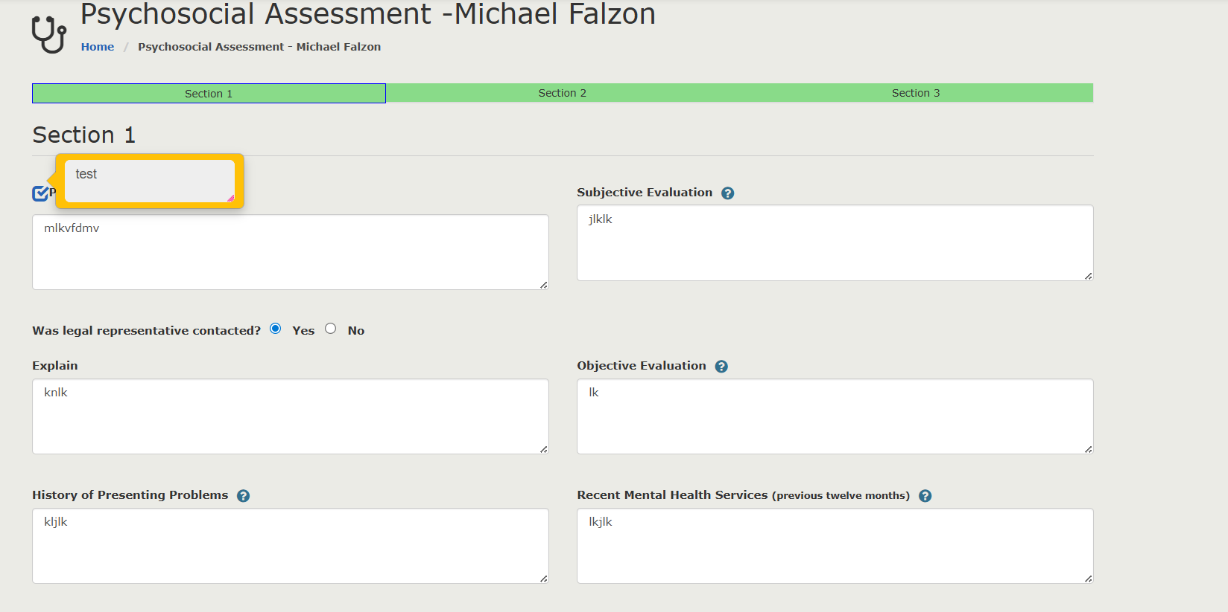

Step 6: Change the description of the text box where the highlighted orange bordered box is present

Step 7: Navigate to Section 3, click on “By checking the box…. Message” and Submit the form.

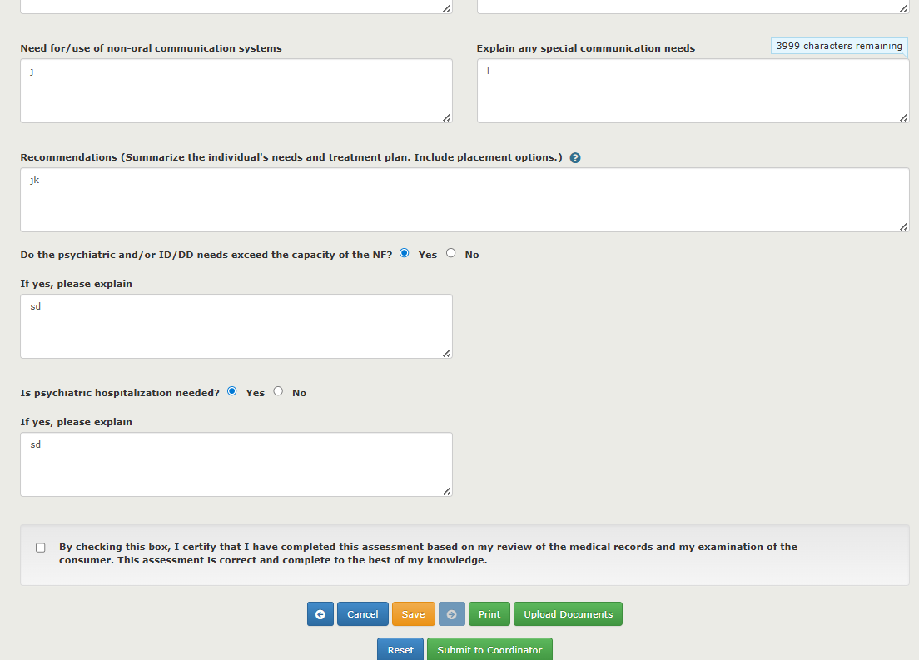

Step 8: Repeat 5, 6,7 steps for Medical form too.

Go to Assessments module and click on “Medical”



Submit the Medical form after completing the changes.

Step 9: Go back to the Pending queue and click on the record

Step 10: Land on the Assessment forms page.

Click on Psychosocial link.

Land on the Psychosocial assessment.

Step 11:

Navigate to section 3 .

Scroll down, click on “By checking the box” and then click on “Approve”.

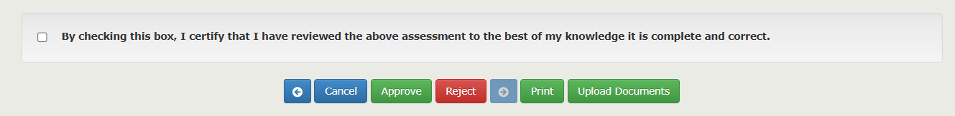

Step 12:

Perform Step 10 and 11 for Medical form.

Navigate to Section 6

Scroll down, click on “By checking the box” and then click on “Approve”.

Step 13:

Click on Next button

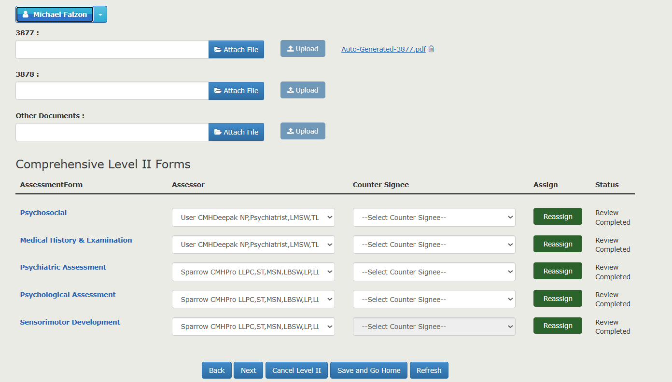

Step 14:

Land on CMH Coordinator form.



Click on “By Checking this box” message checkbox and Click on “Next”

Step 15:

Land on Evaluation Diagnosis and Recommendation screen. Click on “By Checking this box” message checkbox and Click on Save.

